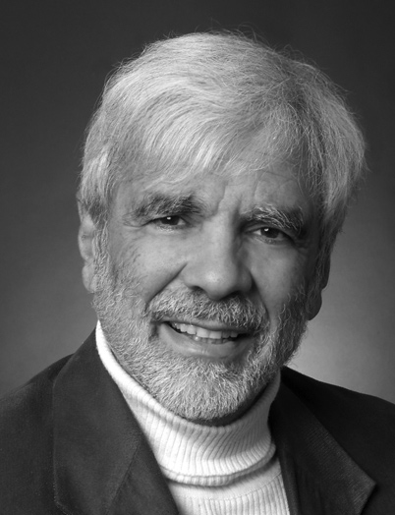
Jonathan V. Wright, MD
b. 1945
Hall of Fame 2012
Dr, Wright is one of the smartest clinicians I have ever met. His remarkable insights and medical wisdom have proven miraculous for so many.
- Joseph Pizzorno, ND
Harvard University and University of Michigan graduate, Jonathan V. Wright is a forerunner in research and application of natural treatments for healthy aging and illness. Along with Alan Gaby, MD, he has since 1976 accumulated a file of over 50,000 research papers about diet, vitamins, minerals, botanicals, and other natural substances from which he has developed non-patent medicine (non-"drug") treatments for health problems. Since 1983, Drs. Wright and Gaby have regularly taught seminars about these methods to tens of thousands of physicians in the USA and overseas.
He was the first to develop and introduce the use of comprehensive patterns of bio-identical hormones (including estrogens, progesterone, DHEA, and testosterone) in 1982 and (at Meridian Valley Laboratory) directed the development of tests to ensure their safe use. He teaches use and laboratory monitoring of bio-identical hormones at several seminars each year.
He also originated successful natural treatment for elimination of childhood asthma, popularized the use of D-mannose treatment for E. coli urinary tract infection, developed effective natural treatment for seborrheic dermatitis, allergic and viral conjunctivitis, and Osgood-Schlatter’s disease, and discovered the effect of cobalt and iodine on estrogen and other steroid detoxification.
Dr. Wright founded the Tahoma Clinic (1973), Meridian Valley Laboratory (1976), and the Tahoma Clinic Foundation (1996). Tahoma Clinic was established to approach disease by natural means and emphasize correction of imbalances in the body that lead to disease. The infamous 1992 FDA Tahoma Clinic "raid" ("The Great B-Vitamin Bust") was a major impetus for Congressional reform of vitamin/mineral regulation. Dr. Wright continues to be an advocate for patient freedom of choice in healthcare.
Internationally known for his books and medical articles, Dr. Wright has authored or co-authored 11 books, selling over 1.5 million copies, with two texts achieving best selling status: Book of Nutritional Therapy and Guide to Healing with Nutrition. He authors "Nutrition and Healing", a monthly newsletter emphasizing nutritional medicine that reaches over 118,000 in the USA, and another 15,000 or more worldwide.

